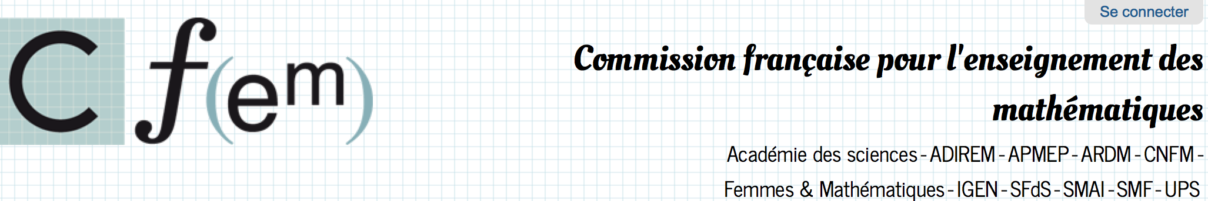

Dear colleagues,

As president of the French Commission for Mathematics Teaching ([CFEM, French commission of the ICMI](http://www.cfem.asso.fr)) and on behalf of its members[1], I send you the application of the IREM network for the first Emma Castelnuovo ICMI award.

The IREM network is born from the collaboration of the French mathematics and mathematics education community: in 1958 the APMEP (French Association of mathematics teachers) president, Gilbert Walusinski, called for the creation of *institutes for teacher training and pedagogical research* (Barbazo 2010). In 1964, the French mathematician André Lichnerowicz suggested to the didactician Guy Brousseau that a *center for research on mathematics teachin*g, involving both mathematicians and mathematics educators, should be created. Two years later, Lichnerowicz coordinated a national official commission which had as its first task to “work out new guidelines for teaching mathematics in primary and secondary school and assess their viability by pilot experiments“ (Gispert 2014). In 1968 the three first IREMs (Paris, Lyon and Strasbourg) were created, after a negotiation between the French Ministry of education and Maurice Glaymann, who was president of APMEP, and became the first director of the IREM in Lyon.

Interestingly, the history of the IREMs is closely linked to the history of ICMI. To give examples: in 1969 the IREM of Lyon hosted the first conference of ICMI, whose president was Hans Freudenthal (Bass 2008) at the time. Two years later Hans Freudenthal created the Institute for the Development of Mathematical Education in Utrecht (today renamed as Freudenthal Institute for Science and Mathematics Education), in the same spirit as the IREMs had been created. In 1985 the IREM of Strasbourg hosted the first ICMI study on 'The Influence of Computers and Informatics on Mathematics and its Teaching', co-chaired byGeoffrey Howson and Jean-Pierre Kahane.

For more than 40 years the IREMs have gathered French researchers and teachers of all levels (primary, secondary, and higher education). The application folder proposed by the IREM network evidences that, since their initiations, the role of the IREMs in France has been crucial for historical, epistemological and didactical developments and reflections in mathematics education, for the development of relevant resources for teachers and teachers educators and of a large number of teacher education devices, for their contributions to the developments of curricula, and for the support of international collaborations. At this moment, when the French Ministry of education and research is to present a strategic plan for supporting mathematics teaching at the national level, the role of IREM will be prominent as a key player in this process.

In this respect, the Emma Castelnuovo award to the IREM network would constitute a support for this network, and an acknowledgment of its key role in the development of mathematics education in France. Furthermore, and at international level, it would provide a strong support for a rare model of mathematics teacher and researcher collaboration over time, for a nexus where all actors of mathematics and mathematics education, teachers and researchers alike, can meet and work together.



Barbazo, E. (2010). *L’APMEP, un acteur politique, scientifique, pédagogique de l’enseignement secondaire mathématique du 20e siècle en France* [*APMEP, a political, scientific and pedagogic actor in 20th century French secondary mathematics teaching*]. PhD. Paris: EHESS.

Bass, H. (2008). Moments in the life of ICMI. In M. Menghini, F. Furinghetti, L. Giacardi, & F. Arzarello (Eds.), *The first century of the international commission on mathematical instruction (1908-2008). Reflecting and shaping the world of mathematics education* (pp. 9-24). Instituto della Enciclopedia Italiana.

Gispert, H. (2014). Mathematics education in France, 1900-1980. In A. Karp & G. Schubring (Eds.), *Handbook on the History of Mathematics Education* (229-240). New York - Heidelberg - Dordrecht - London, Springer

1. Académie des sciences, Assemblée des directeurs d’IREM, Association pour la recherche en didactique des mathématiques, Association des professeurs de mathématiques de l’enseignement public, Comité national français des mathématiciens, Société mathématique de France, Société de mathématiques appliquées et industrielles, Société française de statistique, Union des professeurs de spéciales, Femmes & mathématiques.